Brandi Butler
Course: CSD325 – Advanced Python--Assignment: Module 2.2 – Debugging

This screenshot shows the program paused at the breakpoint on the line where it asks for the number of feet. The debugger is active and the company_name variable shows the value entered by the user.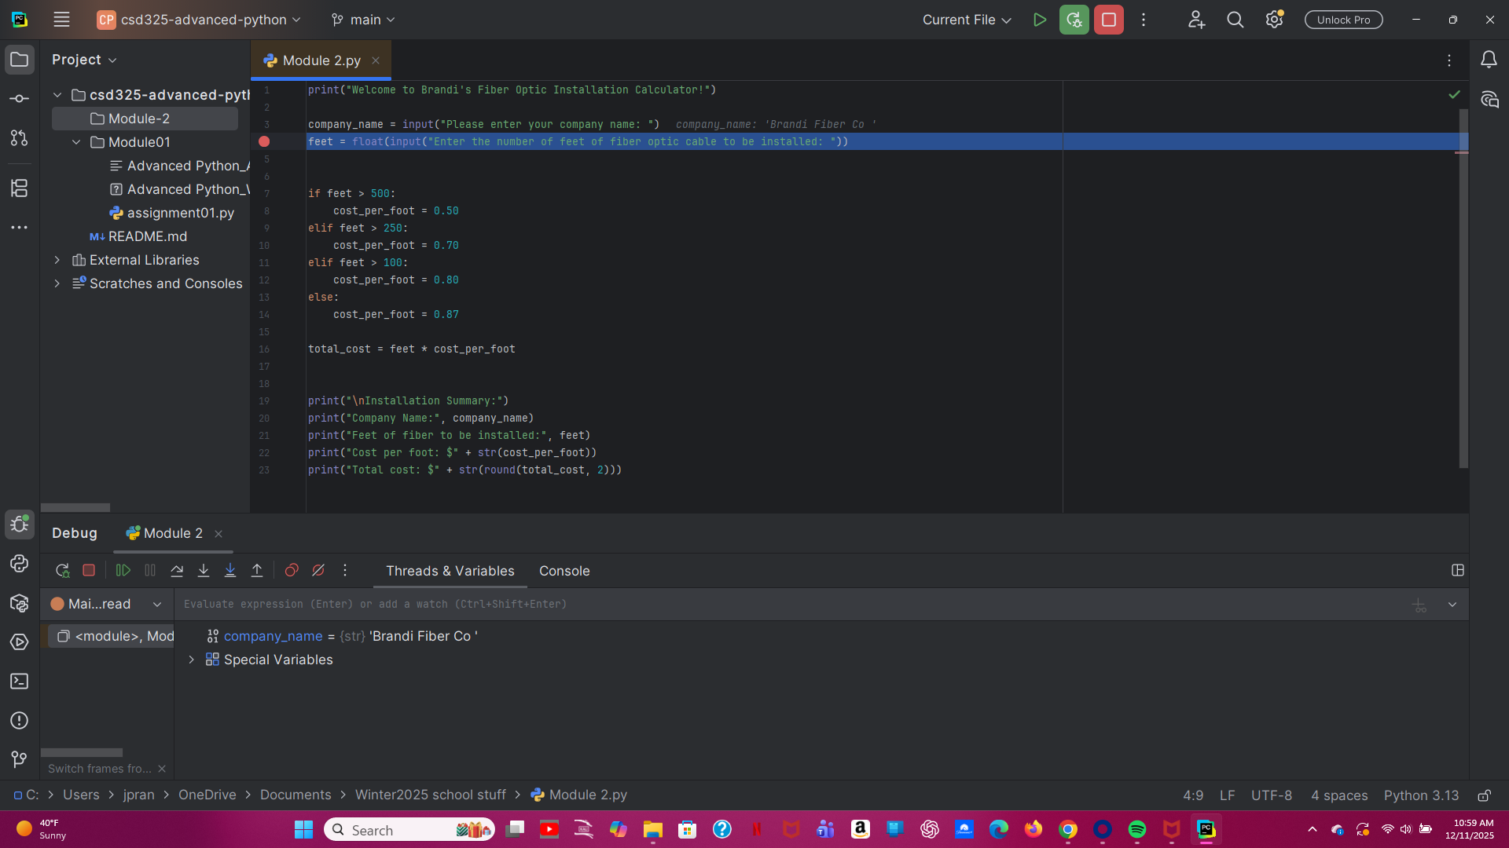

This screenshot shows the debugger stepping into the if and elif statements. Since the user entered 350 feet, the program skipped the first condition and moved to the next one.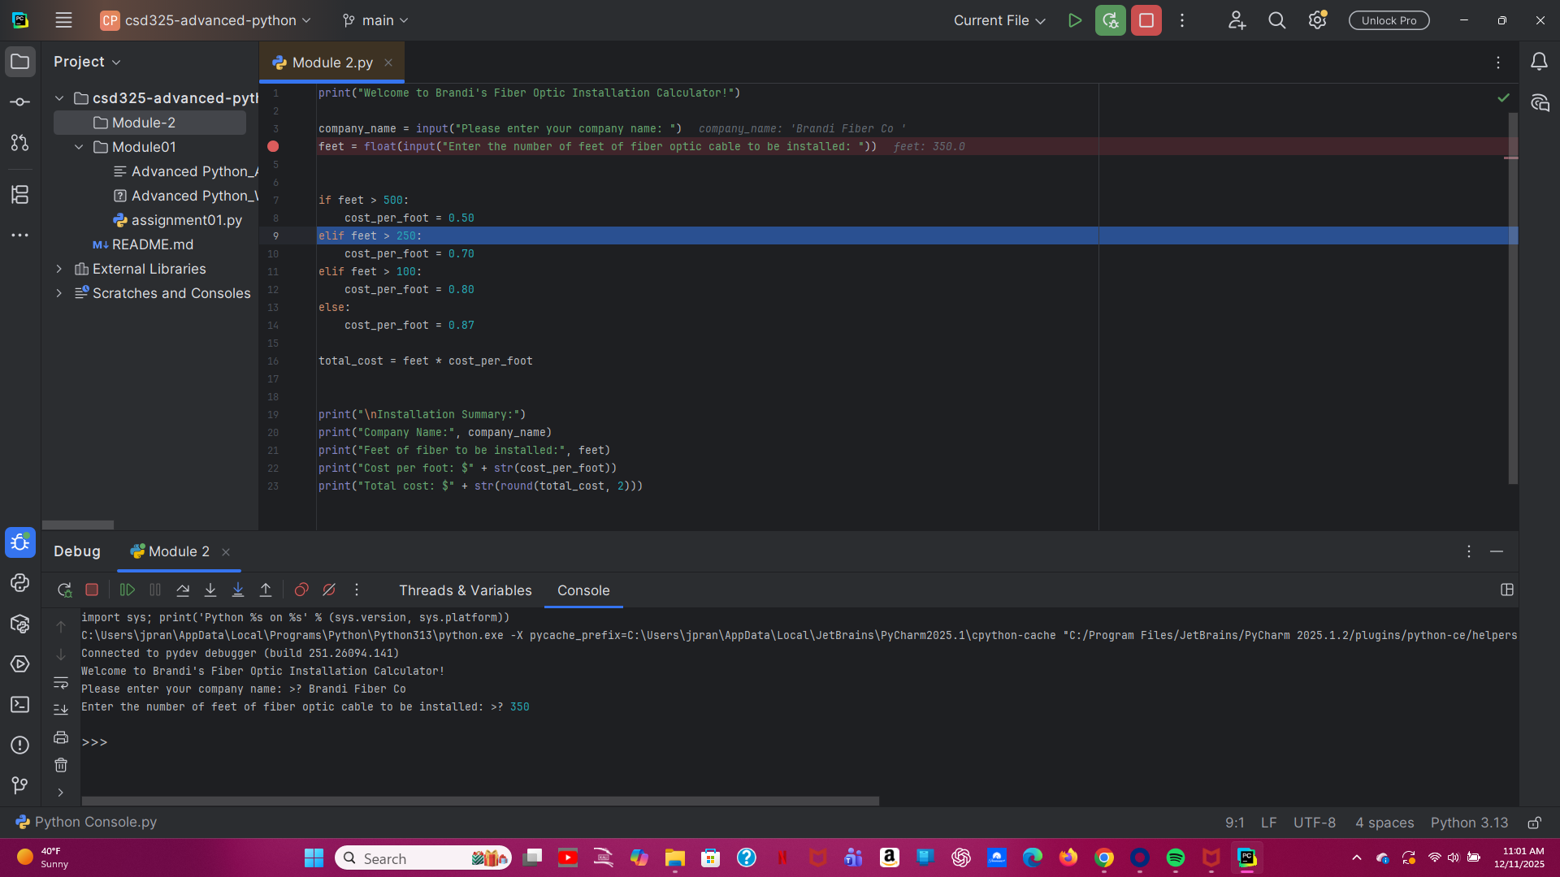

This screenshot shows the debugger reaching the line where cost_per_foot is assigned (0.70). The value is chosen based on the conditions and user input.